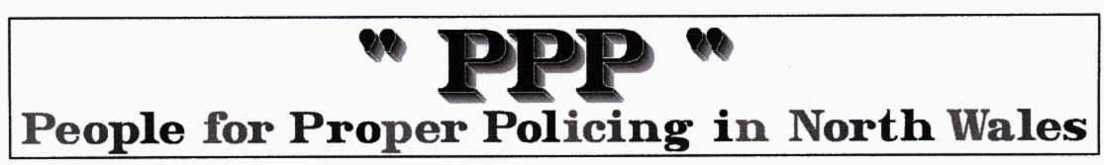
Chief Constable wasted taxpayers money

Feb 7 2008 by David Powell, Daily Post

CHIEF Constable Richard Brunstrom was yesterday dealt a blow when an appeal to house the UK’s first drug-needle dispensing machine in Colwyn Bay was thrown out.

The decision by the Welsh Assembly’s planning inspector brings to an end a year long battle between North Wales Police and Conwy council – at a cost of £50,000.

Residents and politicians were united in their joy last night after government inspector Iwan Lloyd said the potential harm the machine could cause would outweight the benefits.
But they attacked the cost of the fiasco as ‘a waste of taxpayers’ money’.

Conwy council initially rejected the proposal for the machine at Colwyn Bay Police Station – which would have been the first of its kind in the country – in January last year. But North Wales Police appealed against that decision costing the force £25,820, which went to a planning inquiry in November. Conwy council spent £9,728 fighting its corner, arguing that it feared for public safety if addicts regularly visited the machine used to dispense syringes for drug taking, and separate disposal unit in a recess behind Colwyn Bay police station.

Nearby is a youth club which is also used by night school students.

Dismissing the appeal, Mr Lloyd found there were ‘hidden areas’ which were ‘out of sight of (CCTV) cameras’ especially ‘under the cover of darkness’.He said: “The fear of crime and disorder in the area is not baseless... I can appreciate those public concerns and feelings of unease when returning to their cars in the evening. The harm outweighs the benefits. During the day, when the car park is used by shoppers, the site is easily seen... which may deter users because of a lack of anonymity.”

Councillor Chris Hughes gave evidence for Conwy county council against the North Wales Police appeal. He welcomed the dismissal of the appeal: “I am absolutely ecstatic. Public safety is paramount. It is absolutely appalling. We have a Chief Constable who wants to cut this and that who is willing to waste taxpayers’ money on a frivolous scheme like this.”

MP David Jones said: “This has been a waste of public money.” He criticised the police for buying the machine before they had planning permission. “That was putting the cart before the horse.” The MP also criticised the fact the machine had not been tested in the UK. Brunstrom spotted the model on a trip abroad. He said: “The machine has never been assessed by medical authorities in this country.”

Dismissing the appeal by North Wales Police, the planning inspector said ‘fear of crime and disorder in the area is not baseless’.

And the MP said: “It’s paradoxical that the application by North Wales Police should be turned down on the grounds that it would contribute to crime and disorder.”

And Clwyd West AM Darren Millar said the ‘ridiculous proposal’ should have been ‘dropped a long time ago’.

The needle dispensing machine and disposal unit cost about £10,000 of Welsh Assembly money. The needles would have been paid for and replaced by the Welsh Ambulance Trust. North Wales Police spent £25,820 fighting its appeal at a planning inquiry on November 20 and 21 in Llandudno. Conwy County Borough Council spent £9,728.54 defending its refusal to grant planning permission.

The planning inspector was paid £4,332 for his services by the Welsh Assembly Government, at a cost of £722 a day. The total bill to the taxpayer comes to £49,880.54.

RICHARD Brunstrom was unavailable for comment last night after the Planning Inspectorate’s announcement. North Wales Police said it “accepted” the decision in relation to the siting of the needle machine. But a statement on the force’s website indicated the ruling may not be the end of the matter, as the future of the machine, which cost £10,000, must still be decided in Conwy.

The statement read: “North Wales Police, on behalf of the Conwy Substance Misuse Action Team, note and accept the decision of the planning Inspectorate. The future of the Needle Dispensing Machine will now be resolved by the Conwy Substance Misuse Action Team. North Wales Police will make no further comment on the matter.”
The dismissal of the appeal can only be fought with a High Court challenge within six weeks.

The PPP comments … this case was NOT about a needle machine or services for drug addicts it was a power struggle between the people of North Wales supported by their ELECTED representatives and an unelected out of control Chief Constable. Brunstrom expects to do as he pleases with scarce public money. Throughout this shambles the useless Police Authority stood by as they always have done since this disingenuous man came to North Wales.

The machine is WAG property and should be taken to Cardiff for the assembly to decide the best use for it. The rest of the population, including the elderly and disabled, have to plan their visits for their prescription drugs for when the pharmacies are open, DRUG ADDICTS can do likewise.

We congratulate Conwy Council and our representatives and respectfully ask David Jones not to mention Horses as that reminds us of yet another sad wasteful saga and Police Authority failure.

